**Thavy Thach 45868143**

**Brief Description:**

You spawn in “Mighty Pete’s” world, or skybox, and you are a near building that you might not know about. This building is a 3D Model Gallery of objects you might not come in contact with usually. Building is made up of 5 glutSolidCubes, 2 halfPyramids using GL_TRIANGLES, 4 roof-like triangles using GL_TRIANGLES. The GL_TRIANGLES are all texture with three different brick textures, but the walls are not. One of the walls is specularly reflected along with two firelights in the building. When you walk into the interior, you’ll be able to see a lake, specularly lit sheep, vase, firelights, and a snowman.

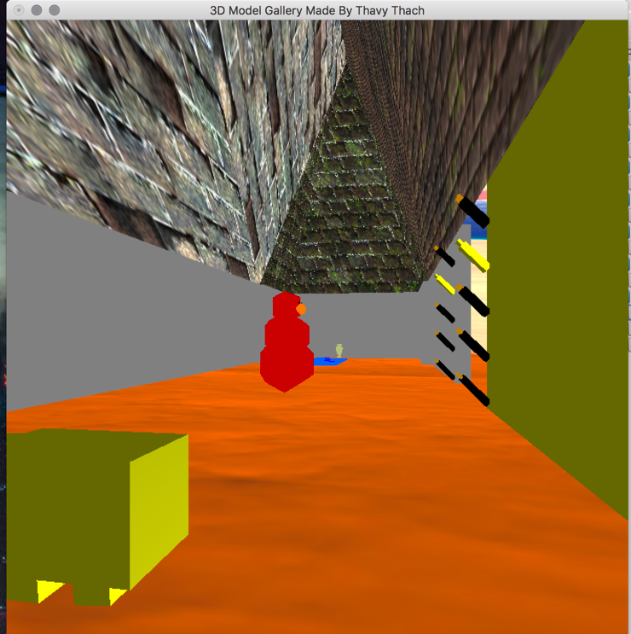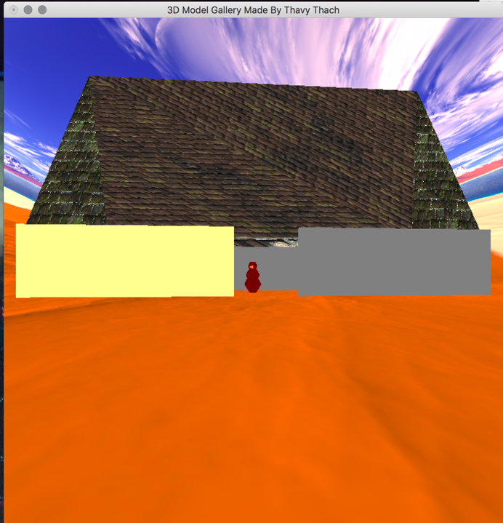

Figure 2... Interior

Figure 1... Exterior

**Extra Features Implemented: N/A**

**Description of Models:**

1. Building() was created using halfPyramid(), 5 GLUT Cube Objects, and 4 Triangles.
   1. halfPyramid() is a pyramid without its 4th (front) side which should not be seen in the interior of the building.
   2. 4 Triangles were created using the vertices at the top of the pyramid and bottom of the pyramid.
   3. One of the 5 GLUT Cube Objects has specular relection.
   4. 3 Brick Textures are used:
      1. One on the halfPyramid()
      2. One on both Two Triangles (front)
      3. One on both Two Triangles (back)
2. Sheep() was created using 6 GLUT Cube Objects where 5 of the 6 objects were used to simulate a sheep walking back and forth. Note sheep has a specular reflection on itself.
3. Snowman() was created using 5 GLUT Cube Objects where the objects change color continuously.
4. Firelight() was created initially for one light, but reiteration allowed to have N lights, where N in this case is 5. All lights glow continuously except when the for loop hits I=3, the light at that point is a specular reflection.
5. Water() was created using 5 GLUT cube objects to create a water flowing effect.
6. Vase() was created using surface of revolution and the animation is glowing different colors continuously.

**Full List of Control Functions:**

1. **GLUT_KEY_UP:** Up Arrow key moves forward.
2. **GLUT_KEY_DOWN:** Down Arrow key moves back.
3. **GLUT_KEY_RIGHT:** Right Arrow Key moves right.
4. **GLUT_KEY_LEFT:** Left Arrow key moves left.

**Resources/References:**

1. <https://www.katsbits.com/download/textures/realistic-brick.php>
   1. Author: ken 'kat' beyer
2. <http://www.custommapmakers.org/skyboxes.php>
   1. Skybox was created by 'The Mighty Pete'